Skill-based Assignment Report

**Project repository link**: <https://gitlab.com/rahu619/creditriskassessment>

**Q1) Most important determinants of credit risk application: -**

**a) Present convincing arguments based on insights from the dataset**

Based on observation of the Customer dataset alone, I believe features like Credit History, Age, Savings, Employment Since will be vital for effectively train a model and to predict if a credit card applicant is worthy or not.

The feature ranking (feature selection) has been done with the help of Feature Importance technique, where the whole set of input predictor variables were fed into a random forest decision tree model and based on the feature_importances property of the trained model, the highly important features could be identified. The features will be displayed in a descending manner in the order of importance and this could help one gain a better understanding of the dataset.

The following features had better score in comparison to the other ones - *Status, Duration, Credit Amount, Credit History, Age, Savings, Purpose.*

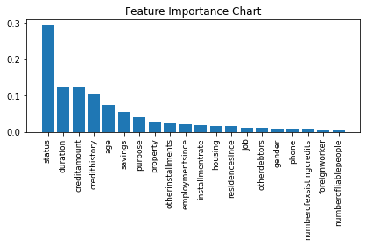

Based on the feature importance ranking, status of the credit applicant is the one of most significant predictor variables in this case. Just like other columns in the dataset it’s a categorical data, that reveals if the credit applicant is holding a checking account, and if yes, is it above 200 Euros.

This feature along with Duration, Credit Amount, Credit History of the applicants could be the most important feature vectors in our case.

The samples were found to be unique enough and there weren’t any NULL values in the records that had to be cleansed. However, since most of the features and the target variable (the credit worthy column) were textual categories, LabelEncoders were used to transform the text data into integers – which were later used for training our models.

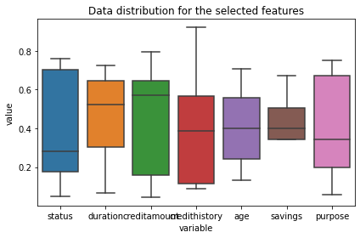

The data outliers in features were found by creating a chart using Box-plot, and these were removed from the DataFrame using Z-score function. The below diagram depicts about the observation box which extends from first quartile to the third one and gives us an idea about the mean of the dataset. This provides us with an idea of how our data is distributed, and if it’s skewed or not.

The outliers will usually appear outside our quartiles and could be identified easily in a box-and-whisker plot like the one given below.

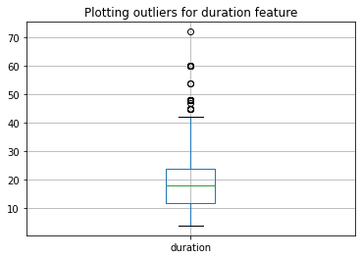

**(b) What are the limitations of your argument?**

Since we don’t have much data sample (988 rows) for training models, potentially the trained models can’t be deployed into production or in a live application. Techniques like Cross-validation might have to considered as well, rather than using the conventional Test Train Split method, as we are working on a limited data sample.

**Q2) The management team wants to use your analysis to propose a system. Can you give an estimate of how accurate your algorithm is likely to be?**

Since we are attempting to predict a categorical result (i.e., if an applicant is credit worthy or not), we will be implementing a supervised classification algorithm.

In this case, I have decided to use the following algorithms and do a comparison between these techniques.

* *k-nearest Neighbours*

*As it’s one of the simplest, and faster classification algorithms that requires less training.*

* *Linear Support Vector Machine*

*Though it’s usually used in high dimension problem scenarios, I wanted to analyse how well it could fare in comparison to other techniques. SVM models also tend to perform better on sparse data as well.*

* *Random Decision Forest*

*Decision trees might be the default approach for a classification problem like this. Implementing random decision forest, as it’s an ensemble of decision trees and it’s likely to be less prone to overfitting and more accurate.*

Once we performed pre-processing and cleaning, the filtered data frame will be fed into our model. And based on the experiments conducted, Random Forest had a better prediction score (~78% at times) which was slightly better in comparison to the other two classification algorithms.

**Q3: What according to you are some of the benefits and risks of adopting such analytics in assessing credit applications.**

Introducing machine learning into such applications could reduce human intervention and also, as it could improve and evolve after deploying, predictive analytics are well suited for such applications. Human made errors could also be bit less, as a trained model will be evaluating such complex cases to determine the credibility of an applicant.

But at the same time, such applications will also require large datasets in order to be properly trained and tasks like understanding business requirements, shortlisting parameters, hyper parameter tuning, pre-processing and transforming data, training model and testing could all be bit time consuming. Furthermore, one needs to have a good domain knowledge apart from the coding, machine learning skills.